VILLAGE OF TIJERAS
FACILITIES RENTAL AGREEMENT
HISTORIC CHURCH
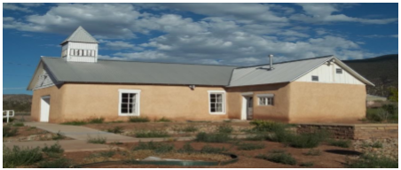
FACILITY FEATURES:
Historical Church (circa late 1800s) including:
• 45 ½’ x 19’ multi use space with small annex attached
• Small raised stage/pulpit/alter
• Podium
• Three power outlets (110)
• Fire extinguisher

ADDITONAL FEATURES (INCLUDED):
- Two (2) indoor trash receptacles with additional liners
- 20 Folding Chairs
FACILITY USE POLICIES
• No alcohol allowed on premises • No smoking allowed anywhere on premises • Neither Renter nor guests will engage in rowdy or unruly behavior • Renter is responsible for removal of waste/garbage produced during rental period • The Park may be open to the public during your event. Please inquire about renting the park and church in one package.
AGREEMENT TERMS
• I agree to pay to the Village of Tijeras a rental fee of $200.00 for the first two (2) hours of use (minimum) and an additional $25.00 per hour for every hour thereafter, for a period of time not to exceed four (4) hours between the hours of 7:00 AM to 9:00 PM. • I agree to pay a cleaning fee of $50.00 which will not be refunded. • I agree to pay a $275.00 damage deposit which will be refunded to me upon inspection of the facility by Village of Tijeras staff. I understand that the damage deposit will not be refunded if the facility is not left in the same condition it was received to the satisfaction of the Village of Tijeras Staff. Additional replacement fees may be incurred for missing items or excessive damage. • Renter agrees to indemnify and hold the Village harmless for and against any and all liability, of whatever kind, arising from injury during the rental period to person or property, caused wholly or in part by any act or omission of renter and/or his/her guests

