VILLAGE OF TIJERAS
FACILITIES RENTAL AGREEMENT
LUIS GARCIA PARK & HISTORIC CHURCH
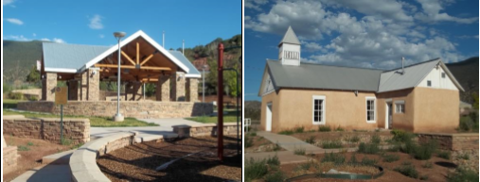
FACILITY FEATURES:
Outdoor park space containing:
• Handicapped access to park features
• 38’ x 38’ covered gazebo with level concrete floor
• Three (3) picnic tables with benches (uncovered)
• Grassy open spaces
• Veteran’s Memorial Wall
• Six (6) outdoor power outlets (110)
• Bathrooms
• Hose spigot
• Playground
• Fence around entire park
• Outdoor lighting
• Fire extinguisher
Historical Church (circa late 1800s) including:
• 45 ½’ x 19’ multi use space with small annex attached
• Small raised stage/pulpit/altar
• Podium
• Three power outlets (110)
• Fire extinguisher
• 20 Folding Chairs

ADDITONAL FEATURES (INCLUDED):
• Two (2) indoor trash receptacles with additional liners
• One (1) outdoor trash receptacle with additional liners
FACILITY USE POLICIES
• No alcohol allowed on premises
• No smoking allowed anywhere on premises
• Renter will not engage in rowdy or unruly behavior
• Renter is responsible for removal of waste/garbage produced during rental period
• No skateboarding is allowed in the park
• Playground is used at renter’s own risk
• Music may only be played at a volume that does not disturb the peace

AGREEMENT TERMS
• I agree to pay to the Village of Tijeras a rental fee of $350.00 for the first four (4) hours of use and an additional $25.00 per hour for every hour thereafter, for a period of time not to exceed eight (8) hours between the hours of 7:00 AM to 9:00 PM.
• I agree to pay a cleaning fee of $75.00 which will not be refunded to me.
• I agree to pay a $275.00 damage deposit which will be refunded to me upon inspection of the facility by Village of Tijeras staff. I understand that the damage deposit will not be refunded if the facility is not left in the same condition it was received to the satisfaction of the Village of Tijeras Staff.
• A LA CARTE ITEMS: I would like to add the following items indicated below by quantity and cost:

