VILLAGE OF TIJERAS
FACILITIES RENTAL AGREEMENT
SENIOR CENTER DINING ROOM
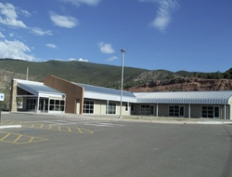
FACILITY FEATURES:
Senior Center Dining Room:
• 6 round tables
• 50 Chairs
• Occupant Load: 100
FACILITY USE POLICIES:
• No alcohol allowed on premises
• No smoking allowed anywhere on premises
• Neither Renter nor guests will engage in rowdy or unruly behavior
• Renter is responsible for removal of waste/garbage produced during rental period
• Renter will not access any room other than the Dining Room
• Use of Kitchen is not included
*Authorized Individual must provide drivers’ license or valid picture ID.
AGREEMENT TERMS:
• I agree to pay to the Village of Tijeras a rental fee of $200.00 for the first two (2) hours of use (minimum) and an additional $25.00 per hour for every hour thereafter, for a period of time not to exceed four (4) hours between the hours of 7:00 AM to 9:00 PM.
• I agree to pay a cleaning fee of $50.00 I understand that the cleaning deposit will not be refunded.
• I agree to pay a $200.00 damage deposit which will be refunded to me upon inspection of the facility by Village of Tijeras staff.
I understand that the damage deposit will not be refunded if the facility is not left in the same condition it was received to the satisfaction of the Village of Tijeras Staff. Additional replacement fees may be incurred for missing items or excessive damage.

