VILLAGE OF TIJERAS, NEW MEXICO

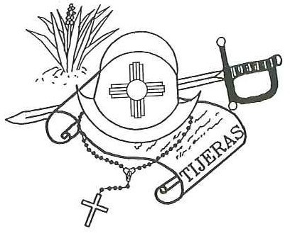
Post Office Box 9
12 Camino Municipal Tijeras, New Mexico Phone: (505) 281-1220
FAX: (505) 281-0948
Email: villageclerk@villageoftijeras.com
Jake Bruton, Mayor

Council: Felix Garcia Don Johnson Maxine Wilson
Yvette Garcia

CONTINUED WORKSHOP
NO ACTION TAKEN

VILLAGE OF TIJERAS
PERSONNEL ORDINANCE
MONDAY, MARCH 2, 2020
5:30PM
VILLAGE CHAMBERS

