VILLAGE OF TIJERAS, NEW MEXICO

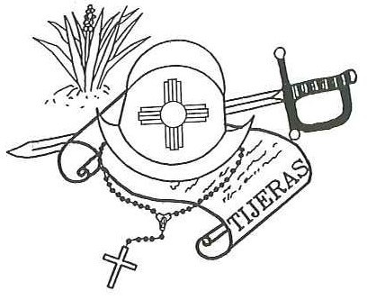
Post Office Box 9
12 Camino Municipal Tijeras, New Mexico Phone: (505) 281-1220
FAX: (505) 281-0948
Email: villageclerk@villageoftijeras.com
Jake Bruton, Mayor

Council: Felix Garcia Don Johnson Maxine Wilson
Yvette Garcia

VILLAGE OF TIJERAS
LOCAL CANNABIS REGULATIONS WORKSHOP
TUESDAY, AUGUST 4, 2021
4:00 PM
VILLAGE COUNCIL CHAMBERS

